Solicitation of Bid for Timber
August 29, 2023
You are invited to bid on timber located as follows: 101 acres located in Section 25, Township 31 North, Range 5 West, Shannon County, Missouri. The land and timber is owned by Shannondale Community Center. To view the sale contact forester Jason Deschu at (573) 291-7906.
Description: All trees to be cut have been measured and marked with a spot of orange paint except cull trees which were marked with an “X” and not measured and which may be cut at purchaser’s option.
Species | International ¼ Scale
Red Oaks | 255,785
White Oaks | 76,157
Hickory | 8,793
Total | 340,735
The estimated gross, merchantable volume is as follows

Buyer will have until December 31, 2024 to harvest timber.
**To be in compliance with the Tree Farm program, and due to our location near a known Indiana Bat cave, no harvesting may take place between March 15th and October 31st. **

There will be a showing of the timber on Friday September 8 at 3:00. Meet at the Timber Lodge
on Hwy 19.
This is a “lump sum” sale for the estimated volume only. Although reasonable care has been exercised in estimating volume, no guarantee is made or implied that this volume is recoverable. The sale is for the designated trees and no adjustment will be made for either overrun or underrun. The bidder should determine the number of logs present and bid accordingly. Selection of a winning bid may not be based solely on highest bidder.

Bid Intructions: Mail completed bid to:

Shannondale Community Center
41277 State Hwy 19
Salem, Mo 65560

Bids should be mailed to be received on or before 11 a.m. Monday October 2, 2023. Bid opening will be at 4:00 p.m. Monday October 2, 2023 at Shannondale Community Center. Hand carried sealed bids may be submitted before 4:00 p.m. on October 2nd.

If your bid is accepted, contract must be signed and payment made in full within ten working days from date of notification of bid acceptance. T

The owner reserves the right to Reject Any and All Bids.

Species | 10 | 11 | 12 | 13 | 14 | 15 | 16 | 17 | 18 | 19 | 20 | 21 | 22 | 23 | 24 | 25 | 26 | 29 | Total Result
Black oak | 1590 | 3235 | 6280 | 8061 | 14860 | 12153 | 21536 | 16449 | 29165 | 23369 | 30141 | 15960 | 15833 | 7354 | 4696 | 654 |  |  | 211335
White oak | 6906 | 7296 | 11257 | 6642 | 8222 | 3804 | 3963 | 2413 | 2898 | 1351 | 8048 | 6970 | 4232 | 473 | 870 |  |  |  | 75346
Scarlet oak | 134 | 122 | 517 | 660 | 1188 | 1755 | 2066 | 3127 | 3495 | 4299 | 4687 | 5619 | 7040 | 1084 | 4690 | 2439 | 620 | 909 | 44450
Hickory | 229 | 472 | 1453 | 1155 | 1787 | 860 | 1490 | 609 | 503 |  | 235 |  |  |  |  |  |  |  | 8793
Post oak | 109 | 107 | 261 | 157 |  |  | 177 |  |  |  |  |  |  |  |  |  |  |  | 811
Total Result | 8968 | 11231 | 19768 | 16675 | 26057 | 18571 | 29232 | 22599 | 36061 | 29019 | 43111 | 28549 | 27105 | 8911 | 10256 | 3093 | 620 | 909 | 340735
Estimate of volume by diameter at breast height and species. Int. ¼ scale

Species | 10 | 11 | 12 | 13 | 14 | 15 | 16 | 17 | 18 | 19 | 20 | 21 | 22 | 23 | 24 | 25 | 26 | 29 | Total Result
Black oak | 38 | 55 | 81 | 78 | 114 | 79 | 116 | 74 | 113 | 78 | 88 | 40 | 35 | 15 | 8 | 1 |  |  | 1013
White oak | 167 | 125 | 141 | 65 | 65 | 25 | 23 | 11 | 13 | 5 | 25 | 19 | 11 | 1 | 2 |  |  |  | 698
Scarlet oak | 3 | 2 | 7 | 6 | 9 | 11 | 11 | 14 | 13 | 14 | 13 | 14 | 15 | 2 | 8 | 4 | 1 | 1 | 148
Hickory | 7 | 8 | 21 | 12 | 15 | 6 | 9 | 3 | 2 |  | 1 |  |  |  |  |  |  |  | 84
Post oak | 3 | 2 | 4 | 2 |  |  | 1 |  |  |  |  |  |  |  |  |  |  |  | 12
Total Result | 218 | 192 | 254 | 163 | 203 | 121 | 160 | 102 | 141 | 97 | 127 | 73 | 61 | 18 | 18 | 5 | 1 | 1 | 1955
Count of trees by diameter at breast height and species.
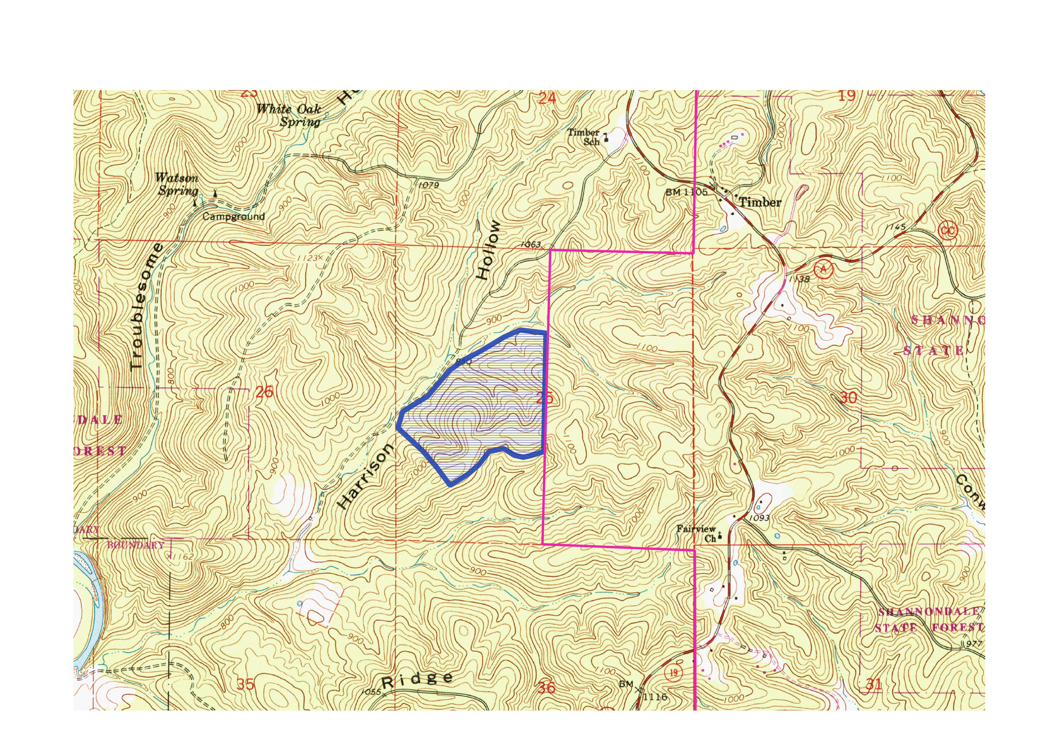
Shannondale 2023 Sale Map
Timber Lodge

Shannondale Community Center Timber Sale Bid

Name of Bidder: ______________________________________

Address of Bidder: _____________________________________
_____________________________________
______________________________________

Telephone: ______________________________

Total Amount of Bid: _________________________________________________
($ _______. ___)
(Lump Sum Bids Only)

Signature: ___________________________ Date: ___________________

