MISSOURI DEPARTMENT OF CONSERVATION
-SOLICITATION OF BID FOR TIMBER-

You are invited to bid on state-owned timber described as follows:
Compartment 3 Tract 302 Castor River Conservation Area in Bollinger County.

ACREAGE & LOCATION: This sawtimber is located on approximately 64 acres on Missouri Department of Conservation.
The area is described as follows: T-30-N, R-8-E Sec.17 See attached map.
There is a SMZ marked on this tract on western half of South line and all BMPs must be followed.

DESCRIPTION:
Species Number Est. Volume (International) Est. Volume (Doyle)
Black oak* 616 125,625 90,659
Scarlet oak 101 24,411 18,124
Post oak 59 6,916 4,349
White oak 139 25,062 18,040
Northern Red oak 53 4,264 11,128
Hickory 111 12,693 7,737
Misc** 40 4,739 8,843
Total 1176 213,710bdft 152,880bdft
* Black oak includes Southern Red Oak
** Misc. includes Ash, Blak Gum,Elm, Poplar, Sweetgum, Walnut and trees deemed as non-commercial

BID INSTRUCTIONS: Only sealed, written, and legible bids will be accepted. NO late, verbal or telephone bids will be accepted. The contract will be awarded based on four bid evaluation categories. The highest lump sum bid may not necessarily be awarded the contract. Categories with missing information will receive zero points. Falsification of any part of this document will result in the rejection of the bid. MDC has the right to reject any and all bids. Bids will be opened promptly on December 14, 2021 at 3:10 pm.

*** Must bid on both Tract 302 and Tract 303 to be considered. Each bid form must be completed and submitted. The best bid system will be used and awarded to the bidder with the highest points when the bids are combined.
The 24-month contract will be awarded within five business days following the bid opening. After a bid is completed, return it to Rt. 5, Box 129, Marble Hill, MO 63764 before December 14th, 2021 at 3:10 pm.
Plainly write “Tract 302 & 303 Timber Bid” on the envelope containing your bid.
Volumes quoted are estimates only and are not guaranteed. Each bidder or their representative should examine the sale to determine volumes present. No acknowledgment of bids received will be given for bids received by mail. SHOWING Thursday December 9th @ 9:00AM meeting at Castor River CA parking by Pine stand off BCR 820.
Bids may also be FAXed on the day of the bid opening, before 3:10pm (time stamp on my machine) to 573-238-0196.
If you have any questions, please contact Nathan Greffe, Forester at 573-238-2321 or nathan.greffe@mdc.mo.gov.

A performance bond in the form of an "Irrevocable Letter of Credit” or other guarantee of performance made out to the Missouri Department of Conservation must be submitted at the time the contract is signed. The performance bond will be in the amount of 5% of the bid price and must be current for the entire length of the contract including any extensions. The contract is to be signed within ten working days following the awarding of the bid.

The service road must be kept open at all times.

*Bid Form on Reverse Side of Page*

MISSOURI DEPARTMENT OF CONSERVATION
Timber Sale Bid Form
Castor River Conservation Area
Timber Sale Tract 302

Category I. Category I contains the lump sum bid by species or total lump sum bid.

ITEM 1:
Subtotal of bid by species:
Red oak species (xxx bdft) $
White oak species (xxx bdft) $
Hickory (xxx bdft) $
Pine (xxx bdft) $
Miscellaneous (xxx bdft) $___________________________________
(elm, maple, ash, walnut, sycamore, etc.)
Volumes quoted are estimates and not guaranteed.
Total Lump Sum Bid
xxx bdft (Int'l. ¼ Tree Scale) $

Category II Missouri Master Logger: Are you currently a Missouri Master Logger or will you have a Missouri Master Logger harvest the sale. Yes No (Yes =25 Points)

*Missouri Master Logger Name: __________________________________

Category III Has any portion of your performance bond ever been held due to contract non-compliance on an MDC timber sale within the last three years? Yes No
(No =10 Points) (Yes=0 Points)
Category IV Training: You will be awarded points based on the percentage of your logging crew that have been through the Professional Timber Harvester (PTH) program and are current with the training requirements. Points will be awarded based on the following ranges:
0-49% of crew members trained = 5 points
50-99% of crew members trained = 10 points
100% of crew members trained = 15 points
Acceptable PTH logging duties include the following:
- Logging Crew Foreman
- Feller
- Skidder Operator
- Topper
- Log deck worker
- Feller buncher Operator
- Forwarder Operator
* Please provide names and certificate numbers. Log truck drivers do not count towards PTH loggers.

Name: _____________________Certificate #_____________________ Job Duty_____________

Name: _____________________Certificate #_____________________ Job Duty_____________

Name: _____________________Certificate #_____________________ Job Duty_____________

Name: _____________________Certificate #_____________________ Job Duty_____________

Name: _____________________Certificate #_____________________ Job Duty_____________

* Loggers named above must remain working for the duration of this contract or be replaced with another Missouri Master Logger and/or PTH trained logger. Failure to replace the lost Missouri Master Logger/PTH logger may result in the termination of contract and withholding of the contracts performance bond. See Instructions.
Name of Bidder:

Address of Bidder:

Phone Number:

Professional Timber Harvester Certificate Number:

Professional Timber Harvester Certificate Date:

Signed: Date:

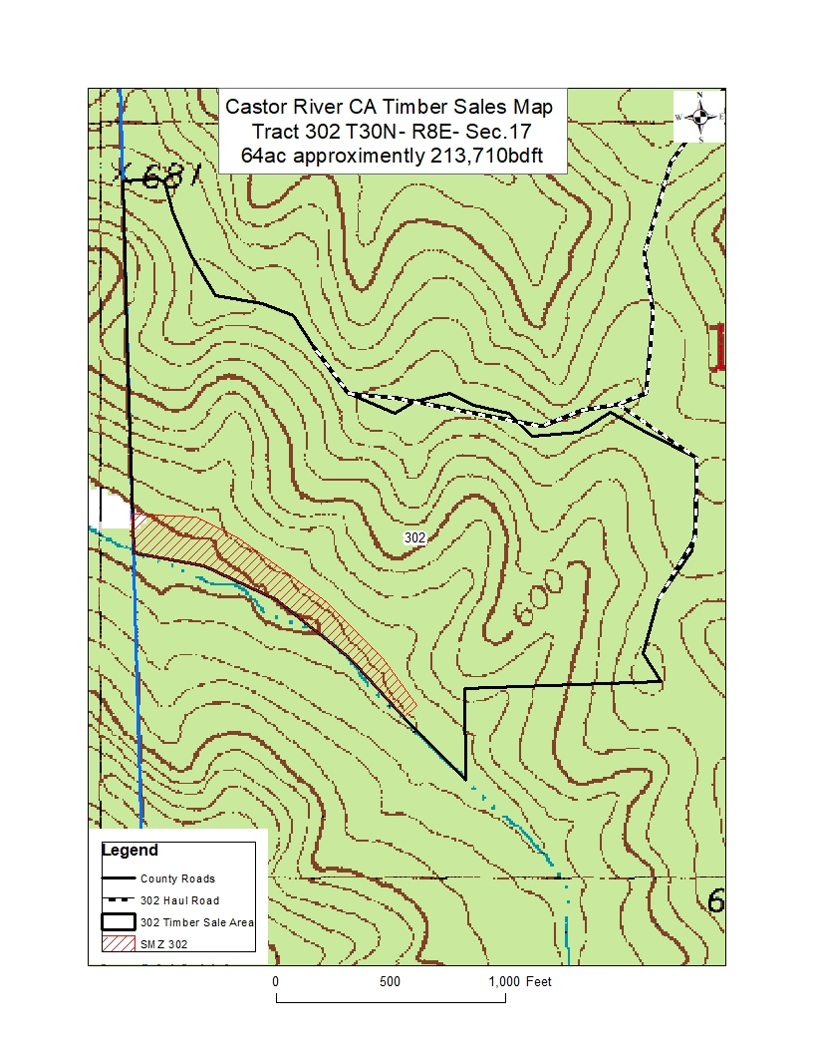

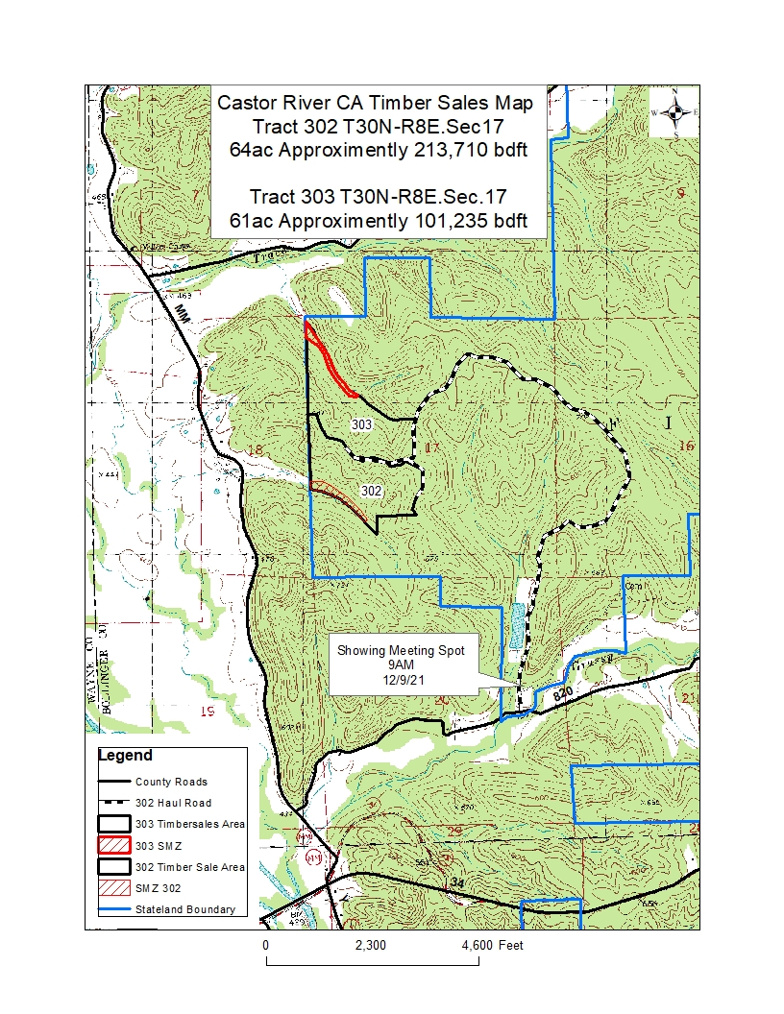

***The Missouri Department of Conservation reserves the right to reject any or all bids. ***

NOTE: “As of November 30, 2002, the Missouri Department of Conservation intends to sell forest products to companies and/ or entities that have proper training. Accordingly, the Missouri Department of Conservation will only accept bids from and enter into contracts in which the individual who is designated to sign timber sale contracts and the individual responsible for supervision of the logging have both successfully completed training, and maintained certification, pursuant to the MFPA Professional Timber Harvester Training or its approved equivalent. Missouri Department of Conservation forest land is certified in the Sustainable Forestry Initiative (SFI) program and supports program objectives.”
Instructions
- Category I. Enter the price per board foot for the specific species listed. (preferred) Enter total lump sum bid in board feet. (mandatory) By entering the price by specific species, you are improving the quality of the Missouri Timber Price Trends.
- Category II. Enter whether or not a Missouri Master Logger will be overseeing the timber sale operations. If you entered “Yes” this Missouri Master Logger must remain on “Contract” during the entire operation. If the Master Logger listed is removed from the contract for any reason the Buyer has 21 days to replace them.
- Category III. Within the last three years has any portion of a performance bond withheld. Circle Yes or No. This applies only the Buyer. New Buyers that have never worked on MDC lands cannot receive 10 pts for performance unless they provide 3 past logging job references that can be verified.
- Category IV. Crews are awarded points based on the number of PTH loggers divided by the total number of crew members. For example a four man crew with three PTH loggers receives 10 points for a crew score of 75%. Because of this it is mandatory to list all crew members on the bid sheet, their certificate number if applicable and their job duty. We can only score by what you list at the time we receive the bid.
The process for adding or replacing crew members:
- You can add as many PTH loggers to the crew as you want during the life of the contract.
- You can only add a non-PTH logger if you remain within the range of points you received in this category. Using the example above we add one non-PTH logger to our four person crew. Now our formula is three PTH divided by crew total of five for a crew score of 60%. We would still be within the 10 point range.
- You can claim a Master Logger in both Category II and Category IV. If this is the case the Missouri Master Logger Must remain both on site and on contract.
- To bid on a Missouri Department of Conservation timber sale you must be a PTH or Missouri Master Logger. You cannot claim points in Categories II and/or IV if you will not be serving in the role of Master Logger or one of the qualifying PTH positions. If you are the Buyer and you are the log truck driver you cannot claim points as a PTH logger in Category IV. You would qualify only as a non-PTH logger.
- No bid will be accepted unless signed and dated. No bid will be accepted if illegible. No late bids will be accepted.
- No points will be awarded for spaces left blank.
The Missouri Department of Conservation does not engage in speculation or assumptions. Therefore we regard the Buyer as having true and legal authority to purchase the sale. All payments to the Missouri Department of Conservation must be made in the name of the Buyer.

