# SOLICITATION OF BID FOR TIMBER

Date: 5/15/2025

You are invited to bid on privately-owned timber described as follows:

**Erlink Kroll Property, 830-864-4144**

**LOCATION:** This sawtimber is located near the town of Roby MO: located in T32N R11W Section 17 all in Texas County, Missouri. **See attached location map.**

**DESCRIPTION** Approximately **57.8** acres of marked mixed hardwood timber, containing approximately **138,369 board feet** (International 1/4" Rule) of sawtimber have been marked for cutting. There are 1,681 trees that were estimated to contain sawtimber volume (SEE ATTACHMENTS).

Neither the owner, or the Missouri Department of Conservation and its representatives will guarantee the accuracy of the volume quoted. Each prospective bidder should examine this timber and **base bid on their own estimate of volume and acres**. The Missouri Department of Conservation and any of its employees are not acting as a legal agent for the owner.

For harvest areas the trees to be sold and cut are marked with a slash of **orange** paint at a point 4.5feet above the ground and again at the base of the tree. Only trees containing merchantable sawtimber volume were included in the above volume quotation. A tree that has a questionable butt log, but that has volume in the top logs is marked with an “X”. Cull and undesirable trees are marked with an "X" and were not tallied or included in the volume estimate (SEE ATTACHMENTS). The successful bidder **MAY** cut and remove **ANY** marked tree. Those trees marked with the word **"DEN"** may not be cut or damaged during the logging operation.

**\***Regeneration group opening areas are marked with orange/black ribbon.

**Timber tour: Timber showing will be on Tuesday June 10th, 2025, at 1:00pm. This is optional for bidders to have a chance to talk with the forester onsite.** The timber may be inspected at any time prior to the bid opening date (See attached maps). For more information feel free to call MDC Forester Nick Cavaness, Houston MDC Office at: (417)-967-3385 ext. 6223, (417)-254-3620, [nick.cavaness@mdc.mo.gov](mailto:nick.cavaness@mdc.mo.gov).

**BID INSTRUCTIONS:** Only sealed, written, and legible bids will be accepted. If desired, bids can be emailed to [nick.cavaness@mdc.mo.gov](mailto:nick.cavaness@mdc.mo.gov) if filled out on the bid form enclosed with this document. No late, verbal or telephone bids will be accepted. The contract will be awarded based on four bid evaluation categories. **The highest lump sum bid may not be awarded the contract**. Based on information provided, the landowners may select the successful bidder on factors other than price alone. Categories with missing information will receive zero points. Falsification of any part of this document will result in the rejection of the bid. **The landowner has the right to reject any and all bids regardless of points awarded or price offered.** Bids will be opened promptly on ***Wednesday, June 25th, 2025, at 3:30 pm at the Houston MDC Office.***

Acceptable bids must be in a lump sum amount for all sale trees. Acceptable bids must also be sealed in an envelope clearly marked "**Kroll** **TIMBER BID**". All bids must be returned to the *Houston MDC Office, 1020 HWY 63 North, Houston, MO 65483 by 3:30 pm, Wednesday, June 25th, 2025.*

**DO NOT ENCLOSE MONEY WITH BID.** The successful bidder will sign the contract and pay what is due within 30 days following the bid opening. Ten percent of the bid will be due at contract signing, with the balance due before any timber is cut. If desired, the sale can be paid for by cutting blocks designated by the Missouri Department of Conservation.

In addition, a performance deposit will be due at contract signing. The performance deposit will be held by the landowner until the satisfactory completion of the contract. If all contract requirements have been satisfied, the landowner will return the performance deposit to the successful bidder.

A sample contract will be available for inspection at the Houston MDC Office. The successful bidder must have the timber cut and removed before July 1, 2026. Extensions may be given due to weather and other factors. All sawtimber not removed at that time shall revert to the seller. All payments will be made to **Erlink Kroll*.***

**\*Bid Form \***

Kroll Sale

**\*\*PTH training is not required to be eligible to bid on this sale**

**Category A**. The price being offered for the timber for sale is indicated here. Volumes are broken out by species and value by species is requested. The Total Lump Sum Bid is required and is the total amount offered for the sale.

***Subtotal of bid by species:***

*Red oak species (77,897 bd. ft.)*  $

*White oak species (42,390 bd. ft.)* $

*Post oak (11,828 bd. ft.)* $

*Hickory & Miscellaneous (6,254 bd. ft)* $

**TOTAL Lump Sum Bid**

138,369 bd. ft. (Int'l. ¼ Tree Scale) $____________________________________

**Bidder Information**

Name of Bidder:

Address of Bidder:

Phone Number:

Professional Timber Harvester Certificate Number:

Professional Timber Harvester Certificate Date:

Signed: Date:

**Category B** **Master Logger**: Are you currently a Master Logger or will you have a Master Logger harvest the sale. Yes No (Yes =25 Points)

*Master Logger Name: __________________________________

**Category C** Have you been recognized by MDC as the State or Regional Logger of the Year? Yes No (Yes =10 Points) (No=0 Points)

**Category D** **Training**: You will be awarded points based on the percentage of your logging crew that have been through the Professional Timber Harvester (PTH) program and are current with the training requirements. Points will be awarded based on the following ranges:

0-49% of crew members trained = 5 points

50-99% of crew members trained = 10 points

100% of crew members trained = 15 points

Acceptable PTH logging duties include the following:

* Logging Crew Foreman
* Feller
* Skidder Operator
* Topper
* Log deck worker
* Feller Buncher Operator
* Forwarder Operator

* Please provide names and certificate numbers. **Log truck drivers do not count towards PTH loggers.**

Name: _____________________Certificate #_____________________ Job Duty_____________

Name: _____________________Certificate #_____________________ Job Duty_____________

Name: _____________________Certificate #_____________________ Job Duty_____________

* Loggers named above must remain working for the duration of this contract or be replaced with another Master Logger and/or PTH trained logger. Failure to replace the lost Master Logger/PTH logger may result in the termination of contract and withholding of the contracts performance bond.

**Category E. References:** Please provide owner contact information for five of the most recent timber sales you have conducted. The landowner may contact them for additional background information.

**Reference 1:**

Name of landowner: ______________________________________

Address: ______________________________________

______________________________________

Phone number: ______________________________________

**Reference 2**

Name of landowner: ______________________________________

Address: ______________________________________

______________________________________

Phone number: ______________________________________

**Reference 3**

Name of landowner: ______________________________________

Address: ______________________________________

______________________________________

Phone number: ______________________________________

**Reference 4**

Name of landowner: ______________________________________

Address: ______________________________________

______________________________________

Phone number: ______________________________________

**Reference 5**

Name of landowner: ______________________________________

Address: ______________________________________

______________________________________

Phone number: ______________________________________

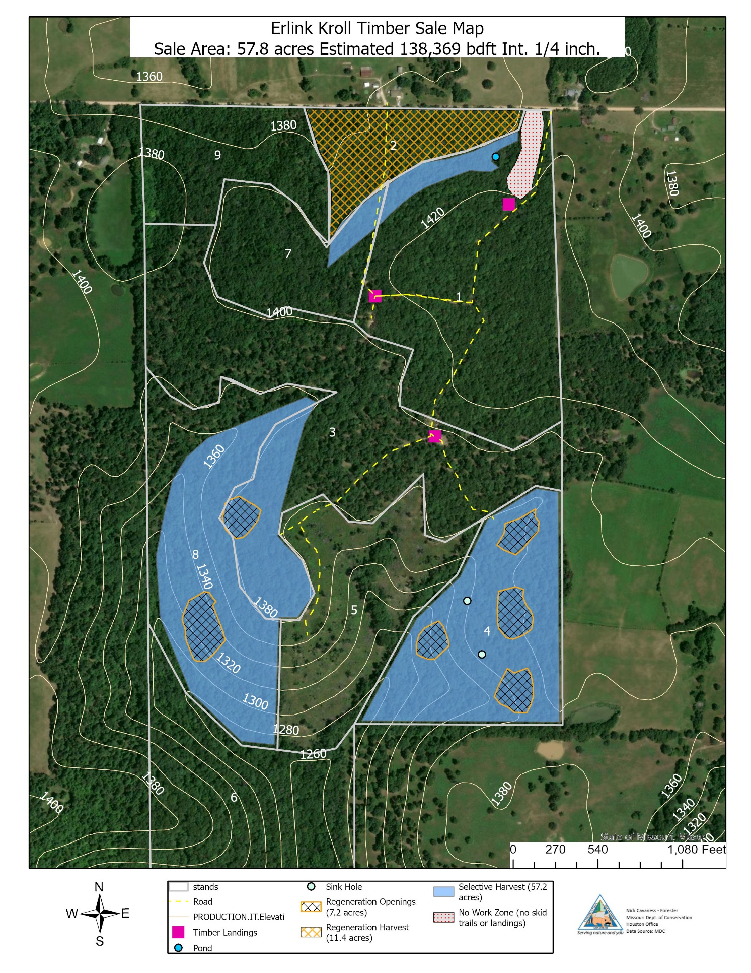

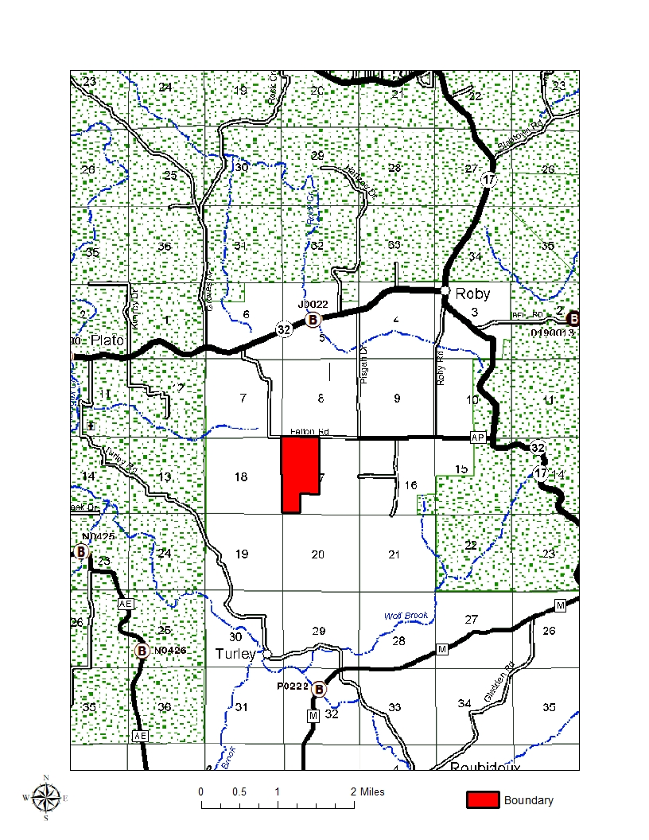

|  |  |  |  |  |  |  |  |  |  |  |  |  |  |  |  |  |  |  |  |  |  |  |  |  |  |  |  |  |  |  |  |  |  |  |  |  |  |  |  |  |  |  |  |  |  |  |  |  |  |  |  |  |  |  |  |  |  |  |  |  |  |  |  |  |  |  |  |  |  |  |  |  |  |  |  |  |  |  |  |  |  |  |  |  |  |  |  |  |  |  |  |  |  |  |  |  |  |  |  |  |  |  |  |  |  |  |  |  |  |  |  |  |  |  |  |  |  |  |  |  |  |  |  |  |  |  |  |  |  |  |  |  |  |  |  |  |  |  |  |  |  |  |  |  |  |  |  |  |  |  |  |  |  |  |  |  |  |  |  |  |  |  |  |  |  |  |  |  |  |  |  |  |  |  |  |  |  |  |  |  |  |  |  |  |  |  |  |  |  |  |  |  |  |  |  |  |  |  |  |  |  |  |  |  |  |  |  |  |  |  |  |  |  |  |  |  |  |  |  |  |  |  |  |  |  |  |  |  |  |  |  |  |  |  |  |  |  |  |  |  |  |  |  |  |  |  |  |  |  |  |  |  |  |  |  |  |  |  |  |  |  |  |  |  |  |  |  |  |  |  |  |  |  |  |  |  |  |  |  |  |  |  |  |  |  |  |  |  |  |  |  |  |  |  |  |  |  |  |  |  |  |  |  |  |  |  |  |  |  |  |  |  |  |  |  |  |  |  |  |  |  |  |  |  |  |  |  |  |  |  |  |  |  |  |  |  |  |  |  |  |  |  |  |  |  |  |  |  |  |  |  |  |  |  |  |
| --- | --- | --- | --- | --- | --- | --- | --- | --- | --- | --- | --- | --- | --- | --- | --- | --- | --- | --- | --- | --- | --- | --- | --- | --- | --- | --- | --- | --- | --- | --- | --- | --- | --- | --- | --- | --- | --- | --- | --- | --- | --- | --- | --- | --- | --- | --- | --- | --- | --- | --- | --- | --- | --- | --- | --- | --- | --- | --- | --- | --- | --- | --- | --- | --- | --- | --- | --- | --- | --- | --- | --- | --- | --- | --- | --- | --- | --- | --- | --- | --- | --- | --- | --- | --- | --- | --- | --- | --- | --- | --- | --- | --- | --- | --- | --- | --- | --- | --- | --- | --- | --- | --- | --- | --- | --- | --- | --- | --- | --- | --- | --- | --- | --- | --- | --- | --- | --- | --- | --- | --- | --- | --- | --- | --- | --- | --- | --- | --- | --- | --- | --- | --- | --- | --- | --- | --- | --- | --- | --- | --- | --- | --- | --- | --- | --- | --- | --- | --- | --- | --- | --- | --- | --- | --- | --- | --- | --- | --- | --- | --- | --- | --- | --- | --- | --- | --- | --- | --- | --- | --- | --- | --- | --- | --- | --- | --- | --- | --- | --- | --- | --- | --- | --- | --- | --- | --- | --- | --- | --- | --- | --- | --- | --- | --- | --- | --- | --- | --- | --- | --- | --- | --- | --- | --- | --- | --- | --- | --- | --- | --- | --- | --- | --- | --- | --- | --- | --- | --- | --- | --- | --- | --- | --- | --- | --- | --- | --- | --- | --- | --- | --- | --- | --- | --- | --- | --- | --- | --- | --- | --- | --- | --- | --- | --- | --- | --- | --- | --- | --- | --- | --- | --- | --- | --- | --- | --- | --- | --- | --- | --- | --- | --- | --- | --- | --- | --- | --- | --- | --- | --- | --- | --- | --- | --- | --- | --- | --- | --- | --- | --- | --- | --- | --- | --- | --- | --- | --- | --- | --- | --- | --- | --- | --- | --- | --- | --- | --- | --- | --- | --- | --- | --- | --- | --- | --- | --- | --- | --- | --- | --- | --- | --- | --- | --- | --- | --- | --- | --- | --- | --- | --- | --- | --- | --- | --- | --- | --- | --- | --- | --- | --- | --- | --- | --- | --- | --- | --- | --- | --- | --- | --- | --- | --- | --- | --- | --- | --- | --- | --- | --- | --- | --- | --- | --- | --- |
| |  |  |  | | --- | --- | --- | |  | |  | | --- | | Timber Sale Report | | |  | |  | | --- | | Information Based on All Survey Data | | |  | |  | | --- | | For Forest: **Erlink Kroll** Stands: **2,4,& 8** (05-14-2025) **75.8 acres** | | |  |  | | |  | | --- | | **Reports for Sale Type:** Tree (Total in Stand) | | |  |  |  | | --- | --- | --- | | |  | | --- | | Volume by Diameter and Species (int 1/4 Inch) | |  | |  |  | | |  |  |  |  |  |  |  |  |  |  |  |  |  |  |  |  | | --- | --- | --- | --- | --- | --- | --- | --- | --- | --- | --- | --- | --- | --- | --- | --- | | Species | Code | 6 | 8 | 10 | 12 | 14 | 16 | 18 | 20 | 22 | 24 | 26 | 28 | 30+ | Total | | Black Cherry | 762 |  |  | 22 |  |  |  |  |  |  |  |  |  |  | 22 | | Black Gum | 694 |  |  |  | 32 |  | 106 |  |  |  |  |  |  |  | 138 | | Elm, spp | 970 |  |  |  | 32 |  |  |  |  |  |  |  |  |  | 32 | | Hickory, spp | 400 |  |  | 682 | 1856 | 1329 | 1266 | 660 | 269 |  |  |  |  |  | 6062 | | Oak, Black | 837 |  |  | 660 | 7611 | 14793 | 20025 | 16194 | 9762 | 5133 | 1978 | 528 |  |  | 76684 | | Oak, Northern Red | 833 |  |  | 44 |  | 123 | 106 | 184 | 467 | 289 |  |  |  |  | 1213 | | Oak, Post | 835 |  |  | 850 | 3504 | 3744 | 2171 | 1388 | 171 |  |  |  |  |  | 11828 | | Oak, White | 802 |  |  | 1144 | 6253 | 8271 | 7745 | 7392 | 5989 | 2935 | 1678 | 636 | 347 |  | 42390 | | -Totals- |  |  |  | 3402 | 19288 | 28260 | 31562 | 25818 | 16658 | 8357 | 3656 | 1164 | 347 |  | 138,369 | |  | |  |  | | | |  |  | | --- | --- | |  |  | | |  | | --- | | Number by Diameter and Species (Int. 1/4 Inch) | |  | | |  |  |  |  |  |  |  |  |  |  |  |  |  |  |  |  | | --- | --- | --- | --- | --- | --- | --- | --- | --- | --- | --- | --- | --- | --- | --- | --- | | Species | Code | 6 | 8 | 10 | 12 | 14 | 16 | 18 | 20 | 22 | 24 | 26 | 28 | 30+ | Total | | Black Cherry | 762 |  |  | 1 |  |  |  |  |  |  |  |  |  |  | 1 | | Black Gum | 694 |  |  |  | 1 |  | 1 |  |  |  |  |  |  |  | 2 | | Elm, spp | 970 |  |  |  | 1 |  |  |  |  |  |  |  |  |  | 1 | | Hickory, spp | 400 |  |  | 31 | 55 | 20 | 12 | 5 | 2 |  |  |  |  |  | 125 | | Oak, Black | 837 |  |  | 30 | 192 | 209 | 187 | 109 | 53 | 22 | 6 | 1 |  |  | 809 | | Oak, Northern Red | 833 |  |  | 2 |  | 2 | 1 | 1 | 2 | 1 |  |  |  |  | 9 | | Oak, Post | 835 |  |  | 38 | 96 | 59 | 25 | 10 | 1 |  |  |  |  |  | 229 | | Oak, White | 802 |  |  | 52 | 159 | 115 | 72 | 52 | 32 | 13 | 6 | 3 | 1 |  | 505 | | -Totals- |  | 0 | 0 | 154 | 504 | 405 | 299 | 177 | 90 | 36 | 12 | 4 | 1 | 0 | 1,681 | |  | |  |  | | | | | |
|  |
|  |
|  |
|  |
|  |